**Jonathan Weaver**

**Test Cases**

| **Input** | **Expected Output** | **Actual** **Output** | **Pass?** |
| --- | --- | --- | --- |
| Selection=1 cubic feet=6 | 6 cubic ft. = 4.821384 U.S. bushels | 6 cubic ft. = 4.821384 U.S. bushels | YES |
| Selection=2 miles=10 | 10 miles = 16.0934 km | 10 miles = 16.0934 km | YES |
| Selection=3 GPA=3.9 | Congratulations, you have graduated Magna Cum Laude! | Congratulations, you have graduated Magna Cum Laude! | YES |
| Selection=9 | Thank you for using the program. Goodbye! | Thank you for using the program. Goodbye! | YES |

**Screen Capture**

**Test Case 1:**

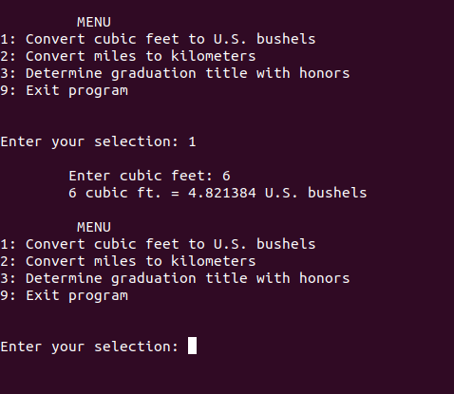

**Test Case 2:**

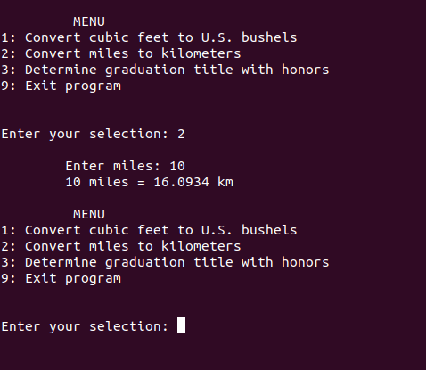

**Test Case 3:**

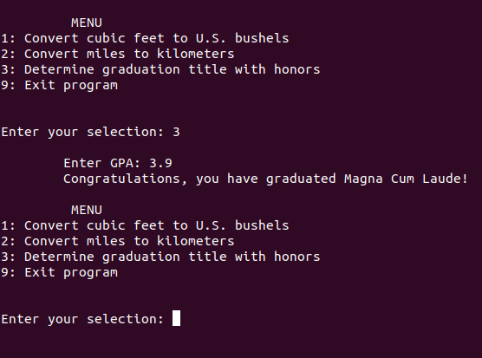

**Test Case 4:**

